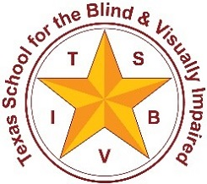
Texas School for the Blind & Visually Impaired
Outreach Program
www.tsbvi.edu | 512-454-8631| 1100 W. 45th St. | Austin, TX 78756

CTEBVI Conference
April 17, 2021
Active Learning Space: A Resource for Families and Professionals

Presented by
Charlotte Cushman, Educational Consultant, TSBVI Outreach
cushmanc@tsbvi.edu
Kate Hurst, Educational Consultant, TSBVI Outreach
hurstk@tsbvi.edu

Developed for
California Transcribers and Educators for the Blind and Visually Impaired

PowerPoint Presentation

Slide 1

Texas School for the Blind & Visually Impaired Outreach Programs
California Transcribers and Educators for the Blind and Visually Impaired (CTEBVI) Conference
Active Learning Space: A Resource for Families and Professionals
Presented by Charlotte Cushman and Kate Hurst, Education Consultants, TSBVI Outreach Programs

Slide 2

Challenges in Implementing an Active Learning Approach
Introductory material available on the Active Learning Space site
www.activeleanringspace.org
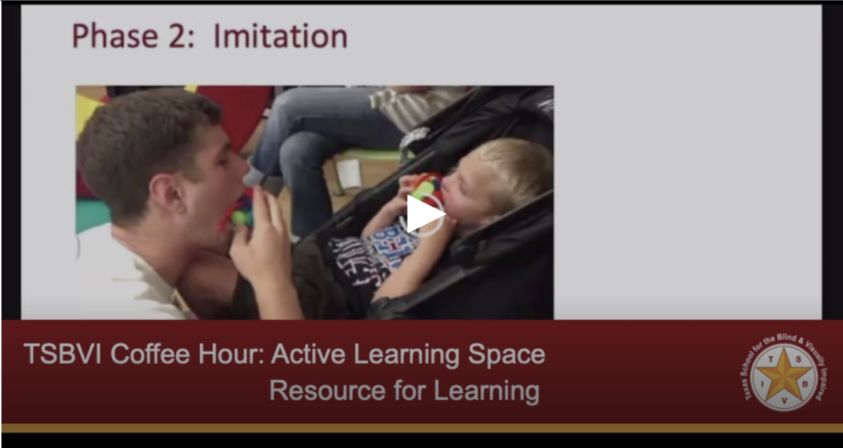
Figure 1 Screenshot of a video on Active Learning Space about Phase 2: Imitation from the Five Phases of Educational Treatment as described by Dr. Lilli Nielsen.
Figure 2 Word Cloud of some of the issues: money, safety, equipment, administration, time, curriculum, buy-in.

Slide 3

Where can I get training on Active Learning?
- Active Learning Space!
- Online courses
- Webinars
- Training of trainers materials
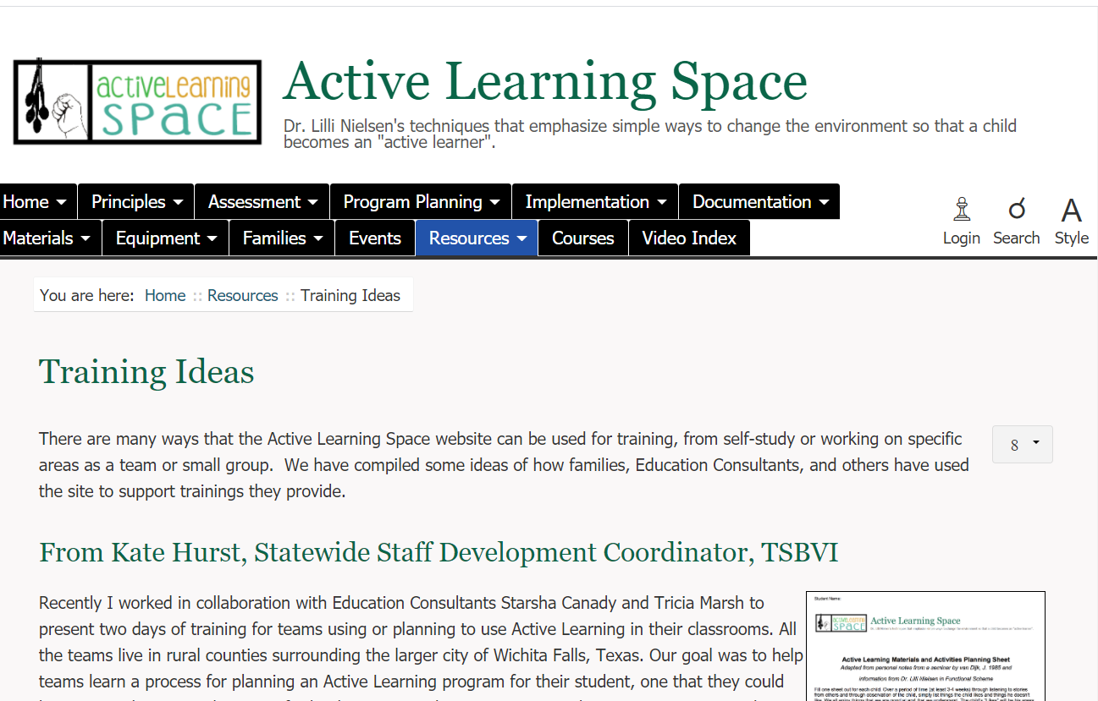
Figure 3 Screenshot of Active Learning Space with Resources tab highlighted.

Slide 4

How can I get my educational team to support this approach?
Before and after Active Learning approach is used https://library.tsbvi.edu/Player/18398

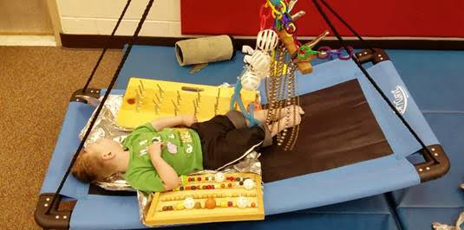
Figure 4 Image from video of Ryland Before and After video.

Slide 5

How do I get parents to support AL?
- Explain why Active Learning works
- Be prepared to answer their questions
- Share the ALS website – Jack’s Progression
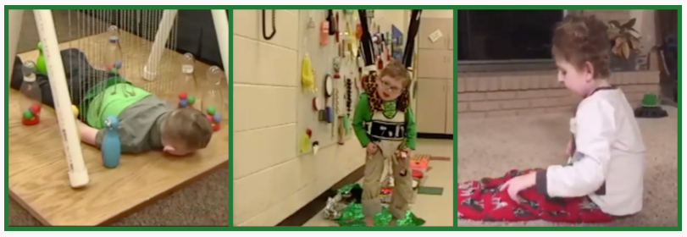
Figure 5 Series of 3 images from the video Jack's Progression showing Jack on his tummy on a Resonance Board, in a HOPSA dress by an Activity Wall, and sitting alone on his living room floor.

Slide 6

How Do I Find the Time or Money to Gather or Make Things?
Check out the Home Hacks ideas!
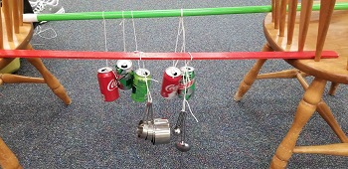
Figure 6 Empty soda cans tied on elastics to broom handles that are wedge between two chairs to make a type of mobile.
You can do a lot with simple, common household items.
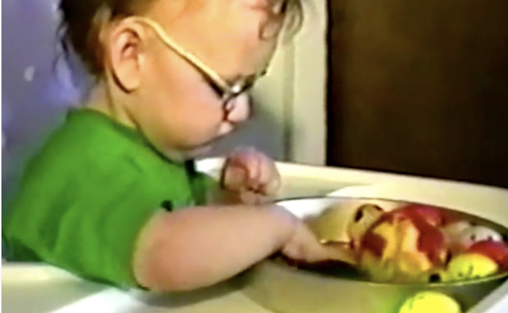
Figure 7 A toddler plays with a metal pan containing various types of small balls such as ping pong, golf, and nerf balls.

Slide 7
We don’t have space to store materials and equipment, what can we do?
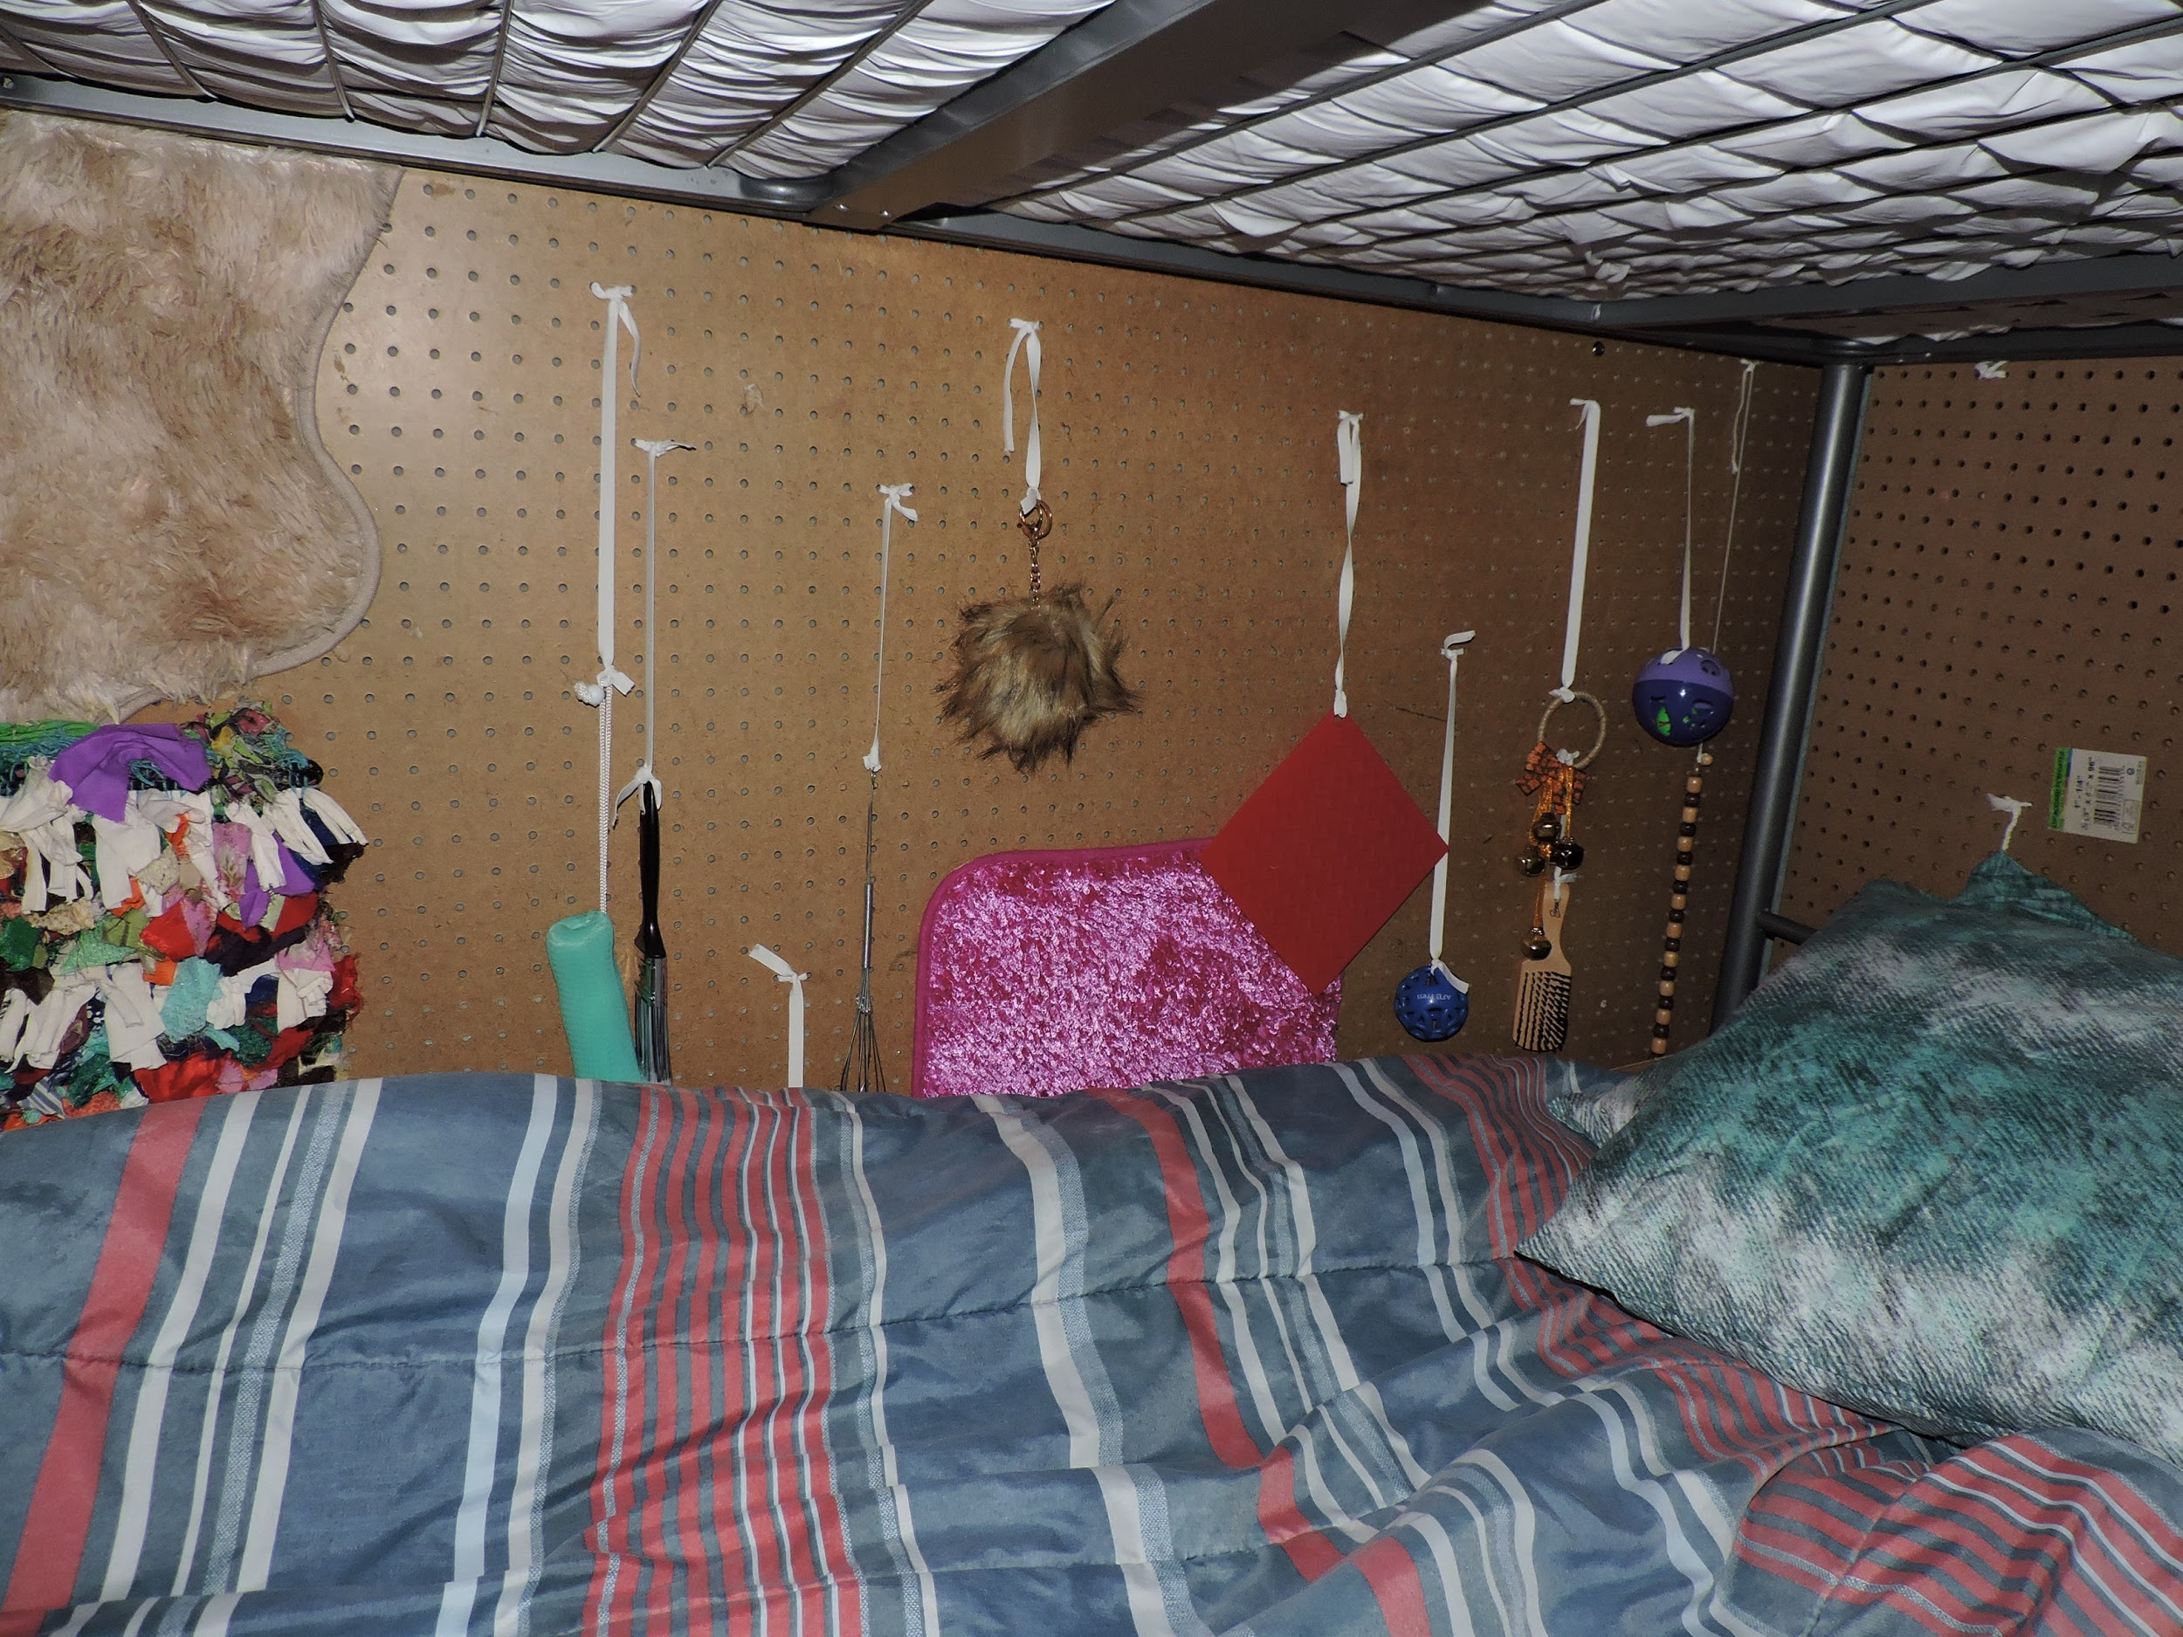
Figure 8 Image of a Position Board attached to a wall beside a child's bed.
Utilize shared spaces such as the gym or therapy rooms
Store items in suitcases
Build folding Resonance Boards
Multiple tops for Little Room
Ask for use of storage closet and move stuff daily
Create a space within the classroom - station
Create spaces at home

Slide 8

Why is it important to limit distractions for the student?
- Don’t want to interrupt the child’s ability to process their learning
- If they’re already having challenges learning, distractions are just one more obstacle.
- Doesn’t need to mean absolute silence, but to limit your comments to natural breaks in the activity.
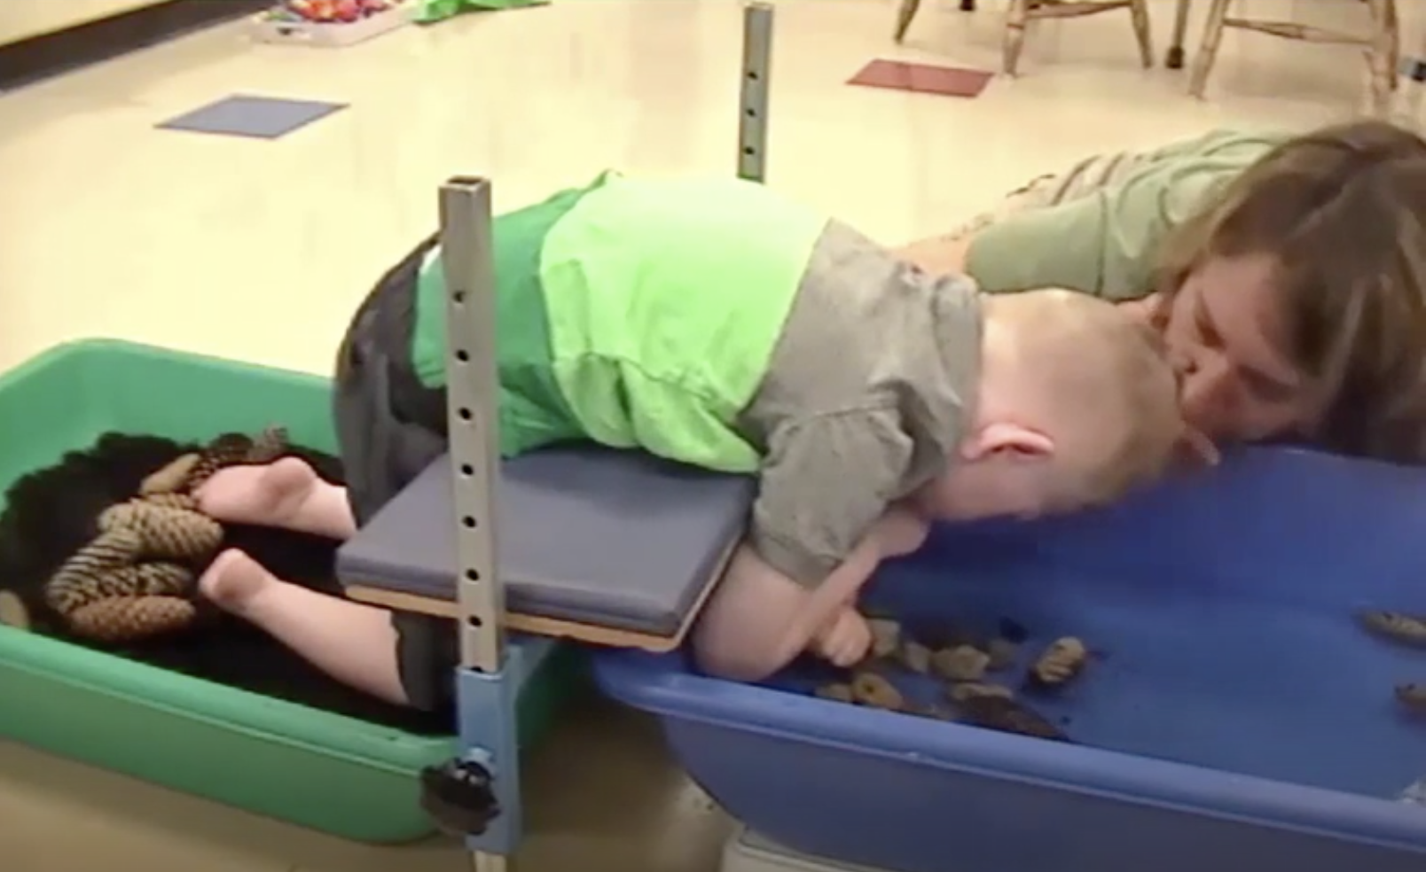
Figure 9 Image from the Video of Jack and the Science Lesson showing Jack on a Support Bench with feet in a container of dirt and pine cones and his hands in a tub of water with rocks. Patty leans into his space to imitate his vocalizations and comment on his ac

Slide 9

Aren’t you afraid the child will get hurt?
- Never leave a child unattended
- Check all equipment each time you use it
- Place plastic tubing over elastics
- Evaluate the child’s strength and skills and address it in equipment/material selection and design
- Make sure you have doctor or therapists approval if child has issues such as hip dysplasia, seizures, etc. – Sonya in the HOPSA

Slide 10
What will my administrator say…?
Pages from Active Learning Materials and Activities Planning Sheet
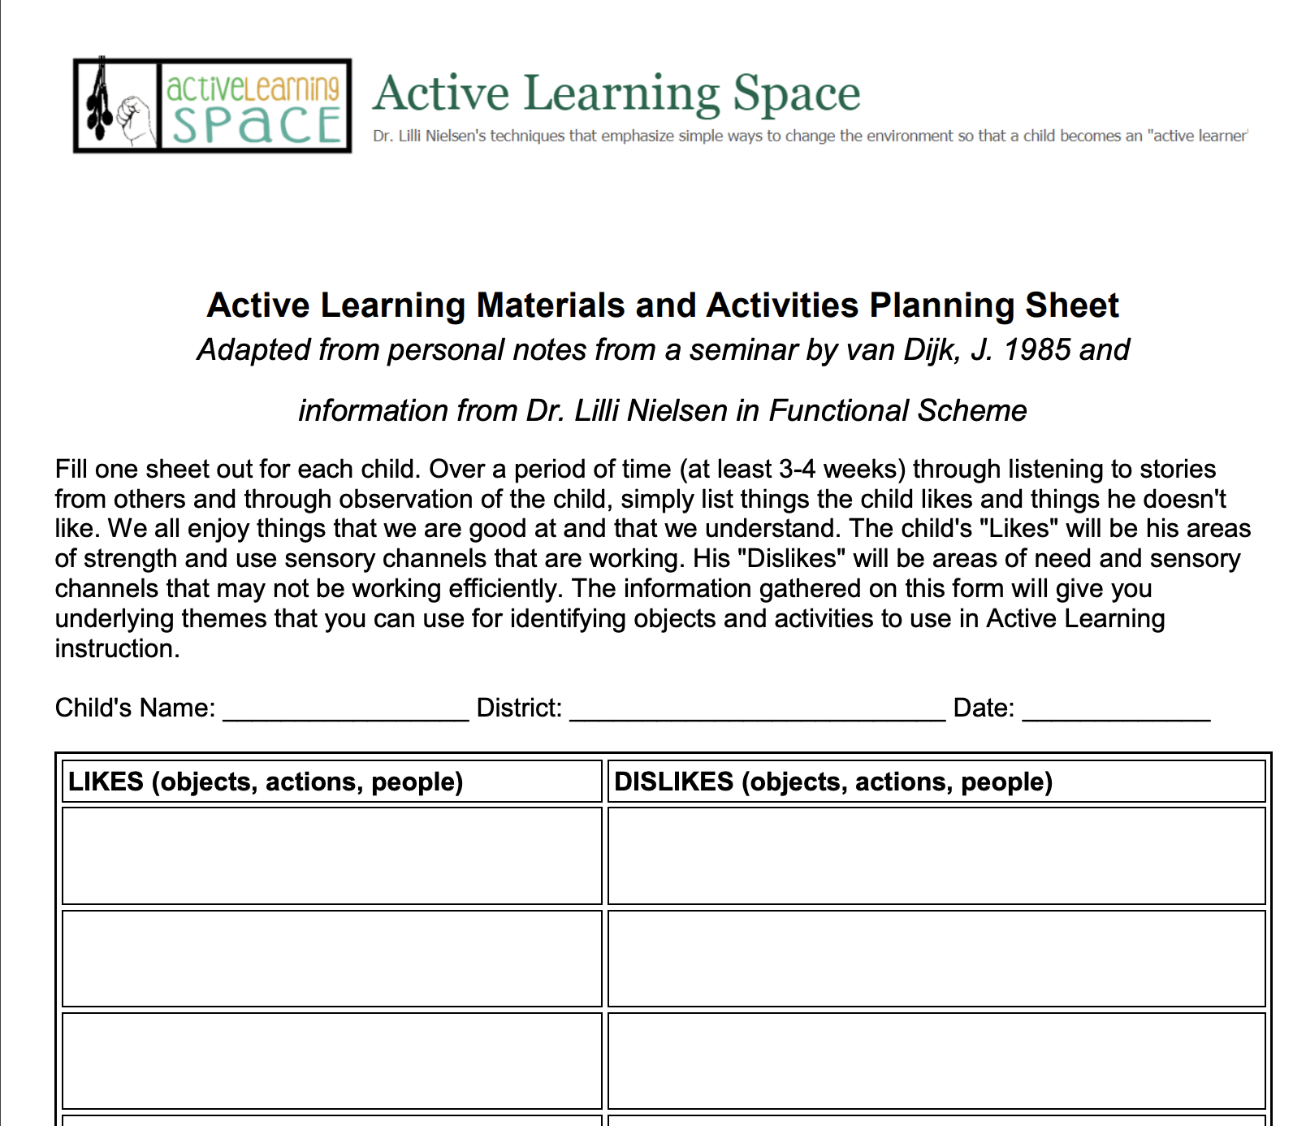
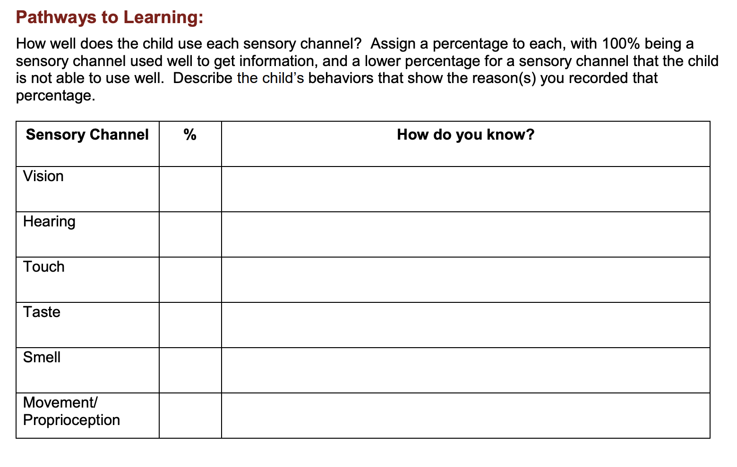
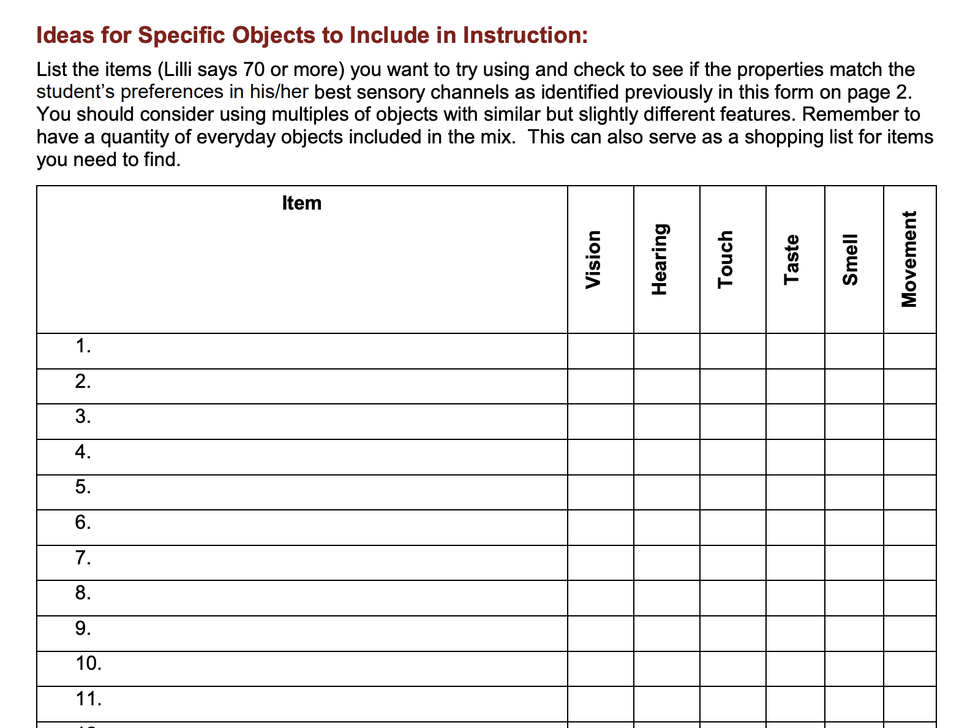
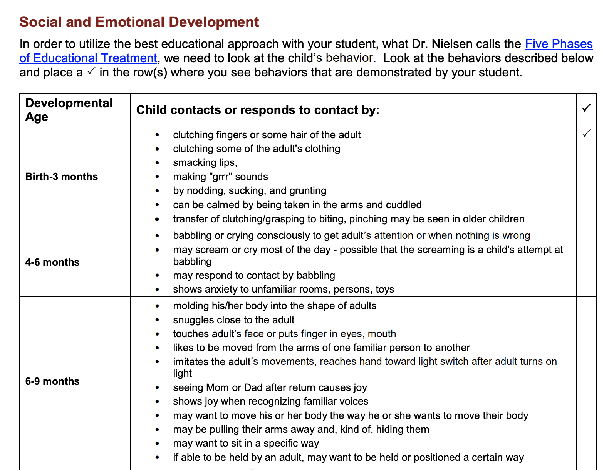
Figure 10 Images of various pages from the Active Learning Materials and Activities Planning Sheet.

Slide 11
How do I address the general curriculum using an Active Learning approach?
- Active Learning and General Education
- Can Active Learning Be Used for General Education
- Resources for Aligning Goals to the Standard Curriculum
- Expanded Core Curriculum
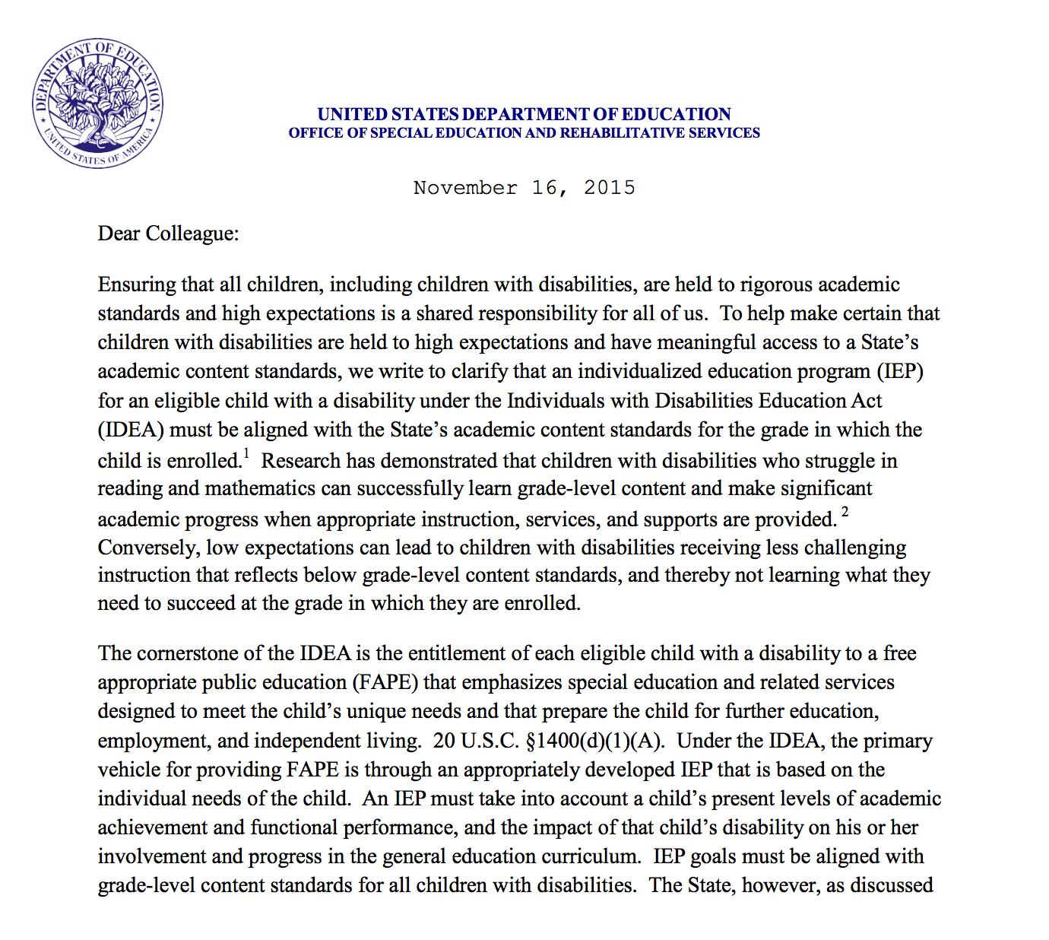
Figure 11 Image of Guidance Letter from Office of Special Education Programs (OSEP) on among other things instruction in the general curriculum for all students.

Slide 12
How do I know what equipment and materials should be selected?
- Look at our Quick Equipment Guide
- Match materials & equipment to learner’s goals
- What does each object do?
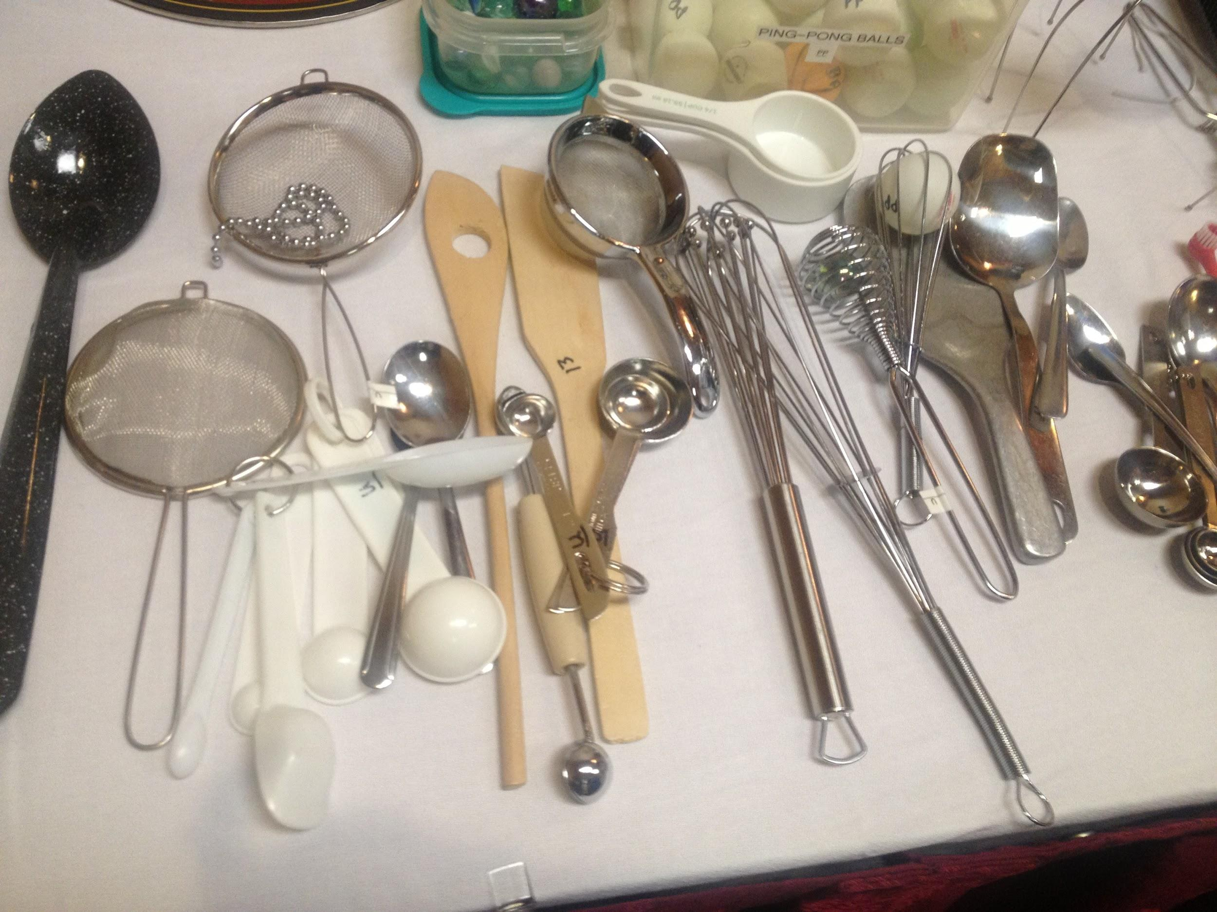
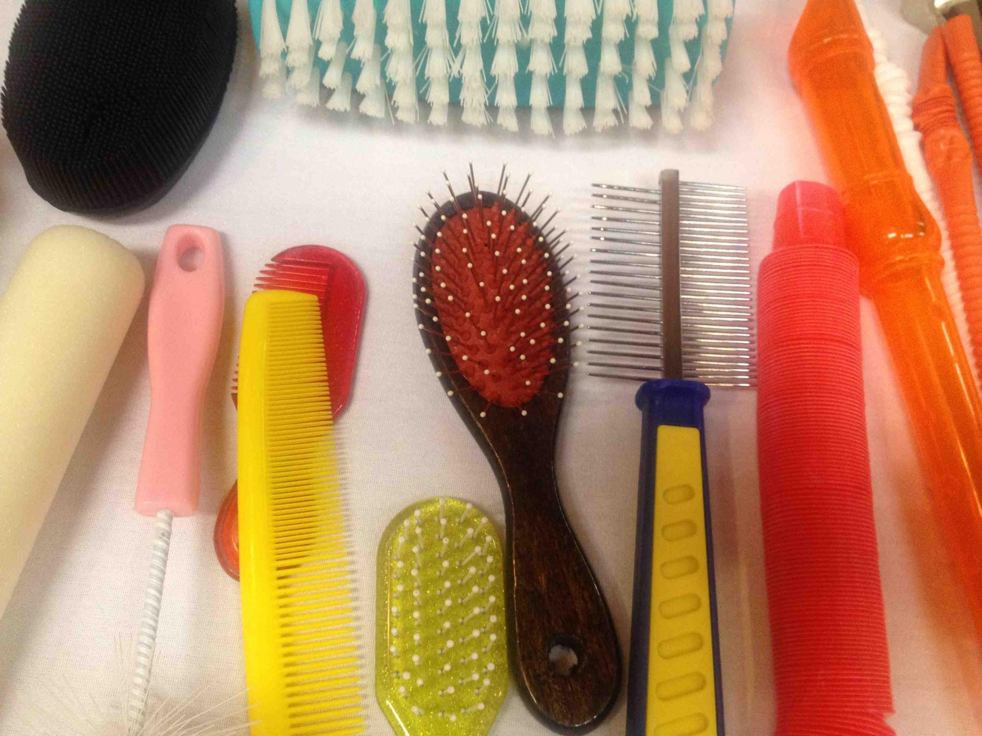
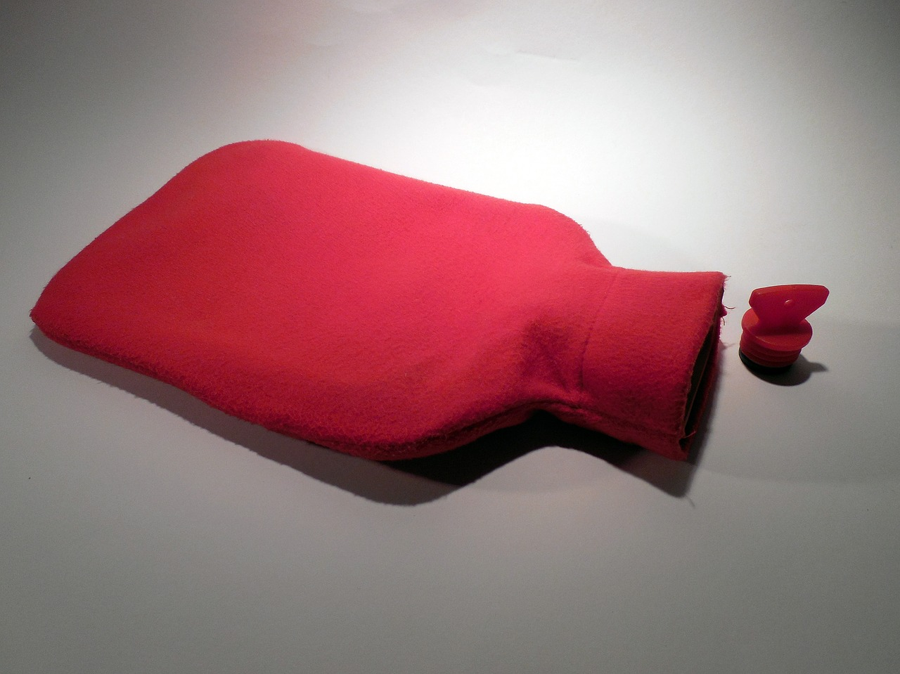

Figure 12 A series of images of common objects used in Active Learning that include: from top left moving clockwise: combs and brushes, strainers and whisks, hot water bottle, rock with hole, nasal syringe.

Slide 13
How do I provide adequate independent and interactive times of instruction?
- FIELA Curriculum
- Look at your existing schedule – identify times when the child is unable to participate or is “resting”, group activities
- Utilize related service staff, therapy time
- Designate paraprofessional and provide role-release support for implementing interaction and independent work
- Think about infusing skills from the IEP into a single activity or learning environment - Goals and Benchmarks that Reflect Active Learning

Slide 14
How should I adapt materials and equipment for students with CVI?
- Vision is not the focus of every activity.
- Be sure you know how the child is using their vision, so that you can plan accordingly.
- Resources on CVI and Active Learning
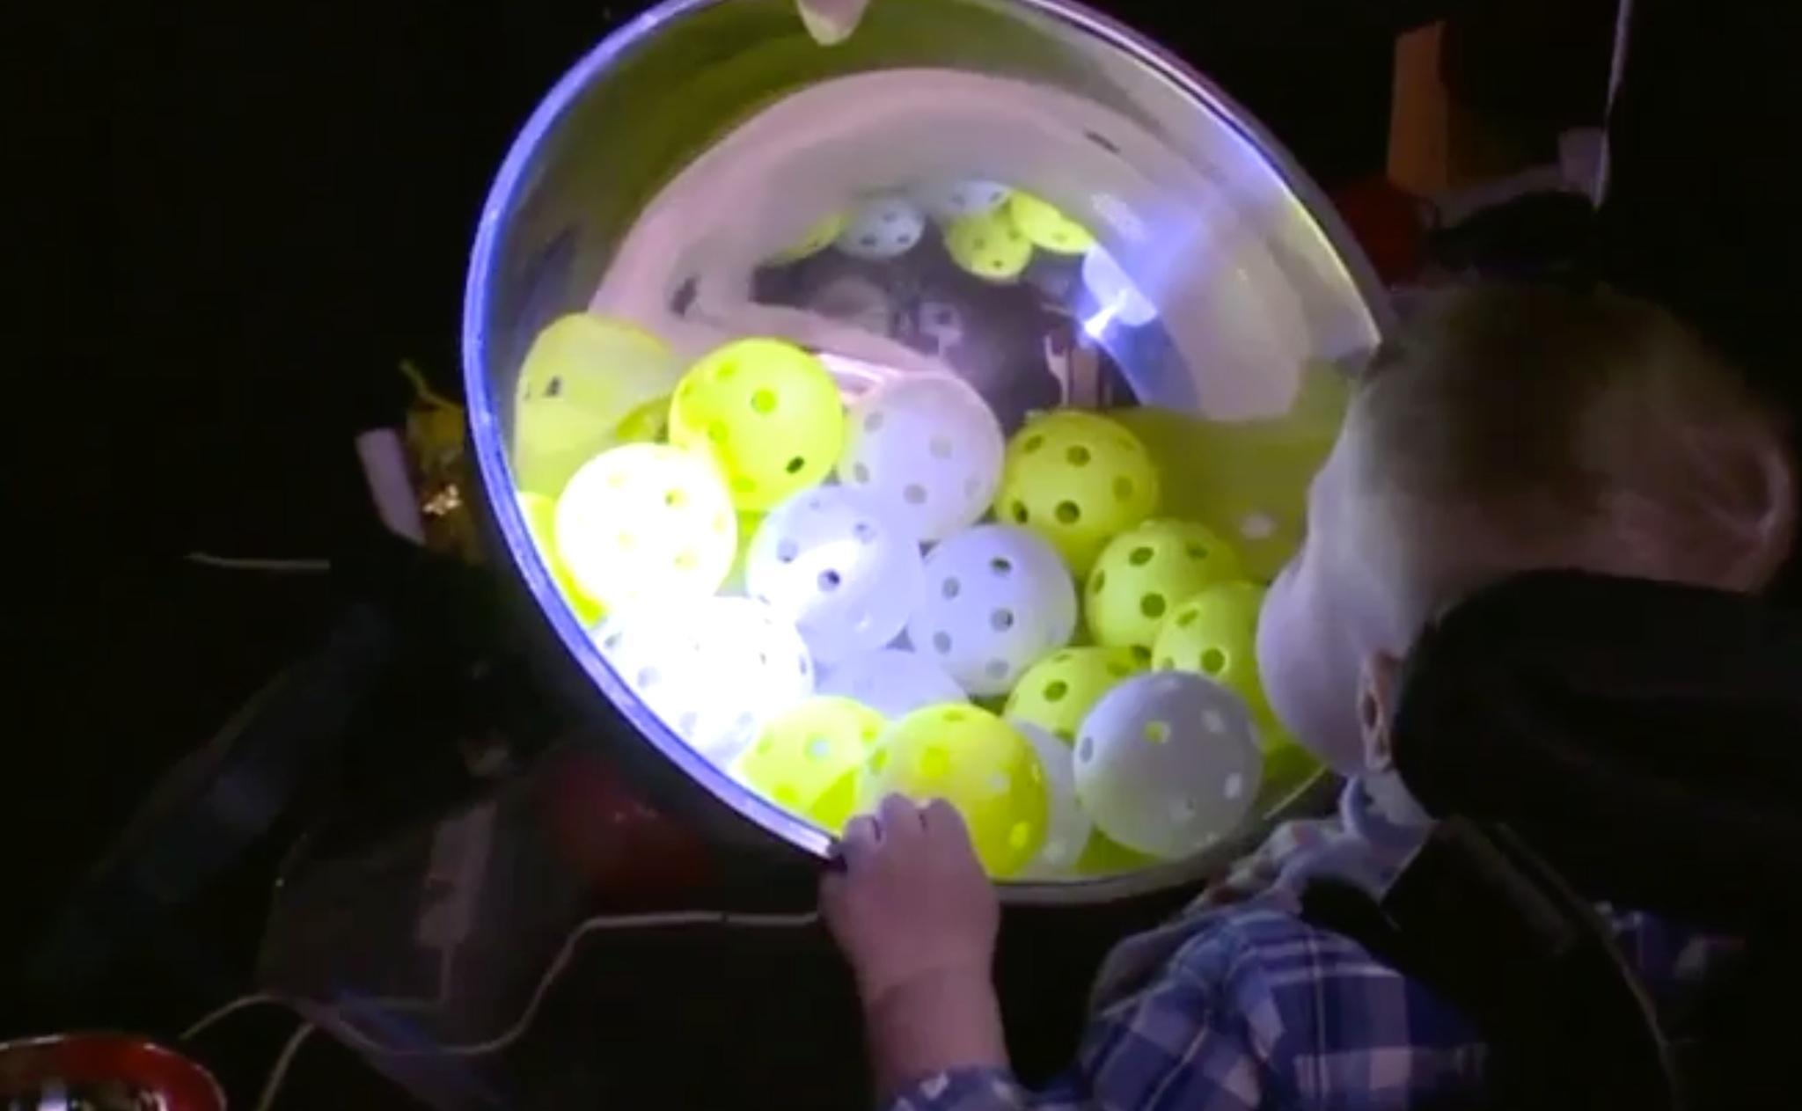
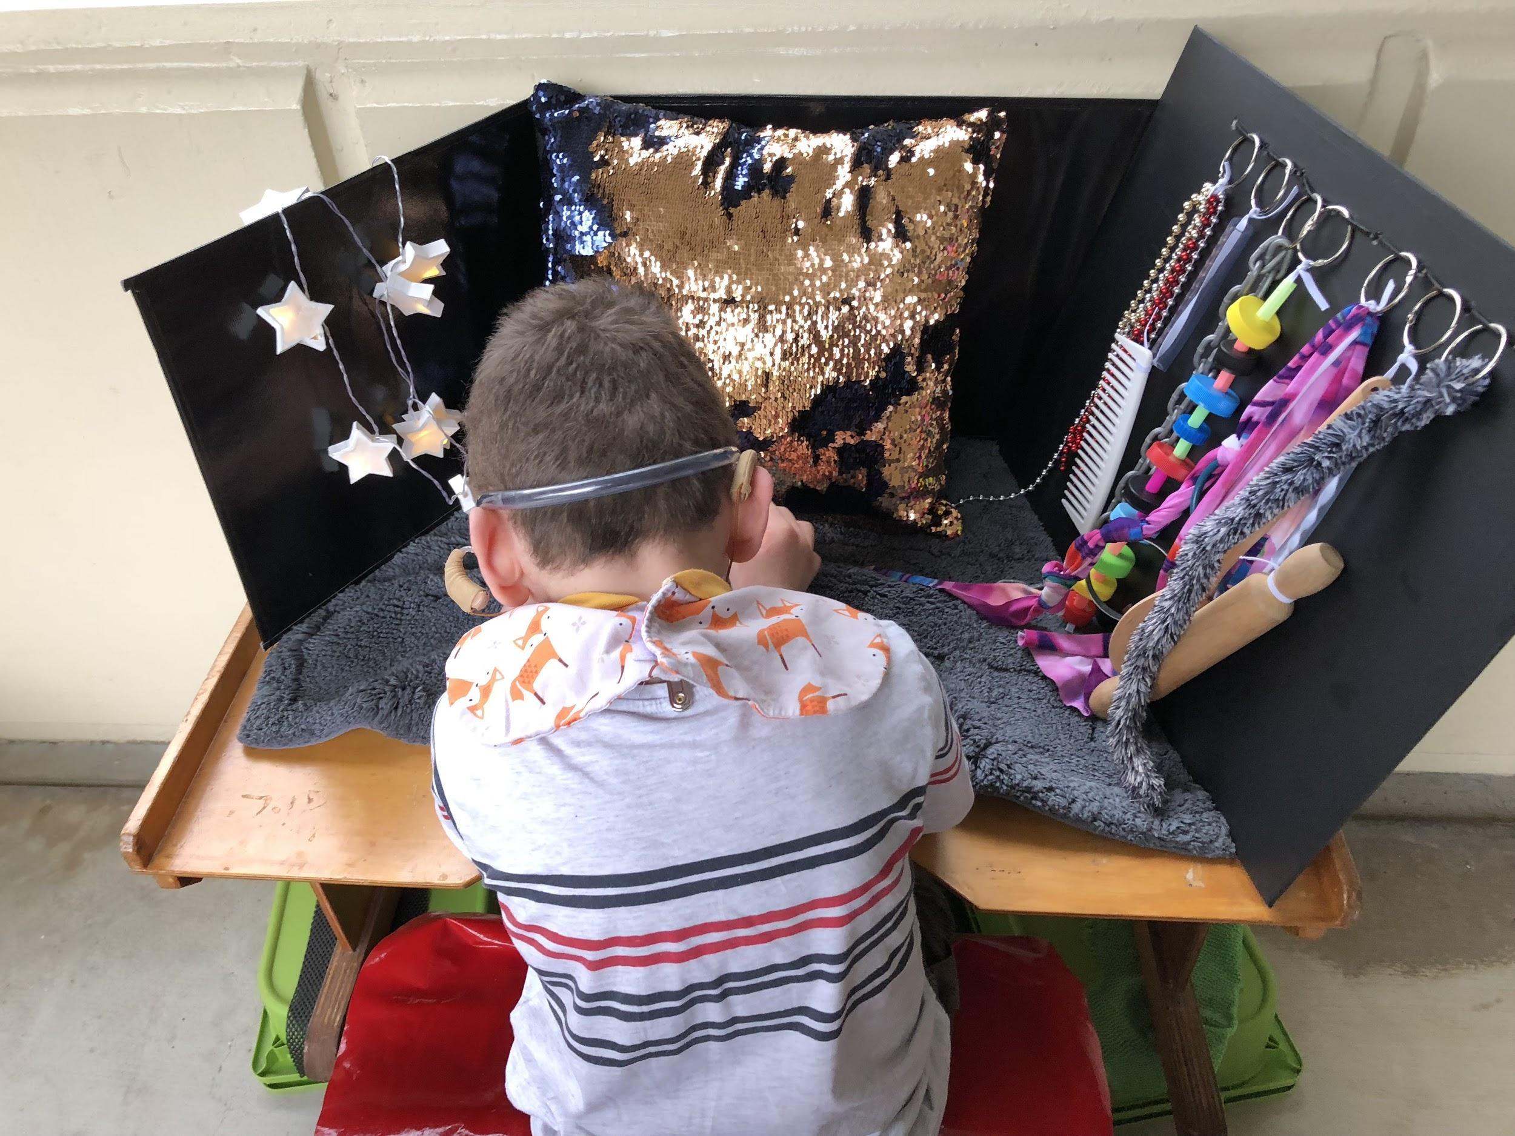

Figure 13 Two examples of materials adapted for CVI students. Top a black desktop corral with items positioned on it and a metal bowl with and yellow nerf and golf balls with a flashlight shining into it.

Slide 15

Questions?
Charlotte Cushman
cushmanc@tsbvi.edu
Kate Hurst
hurstk@tsbvi.edu
Patty Obrzut
patty@penrickton.org

