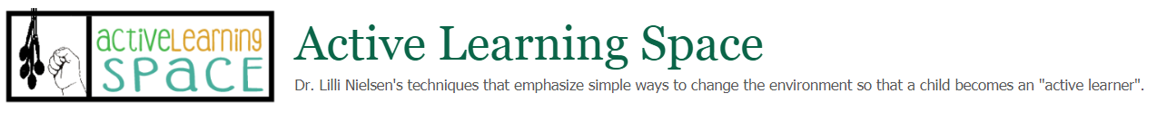

Making Your Own Elastic Boards

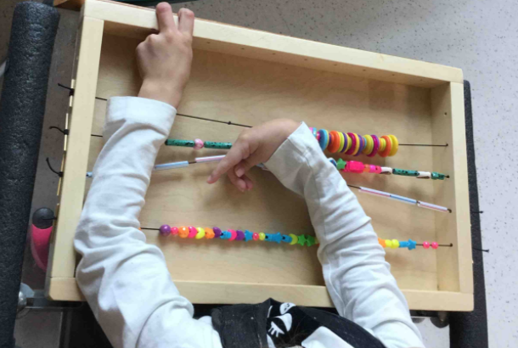
Figure 1 A child uses a horizontal elastic board.
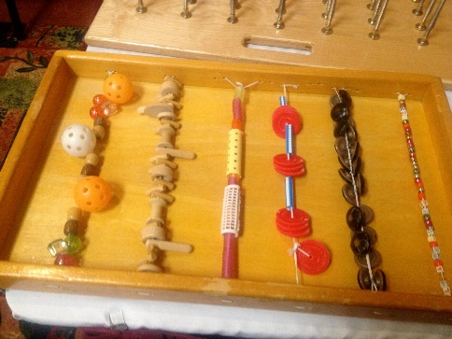
Figure 2 Elastic board with various patterns of objects.

To make an elastic board you will need the following supplies:
- Birch plywood – size can vary, but item shown below is 21×13
- Birch trim 1×1
- 1/8” elastic – minimal width, use larger widths for children that have increased strength
- plastic tubing – optional
- loop turner – optional – available at JoAnn Fabric – for pulling elastic through tubing
- drill – to put holes in wood or items to be placed on boards
- Items to be attached to board
- router – optional to soften edges of board
- sander or sandpaper
- polyurethane
Cut plywood to appropriate length. Cut 1-inch trim to outline the plywood. Assemble board with wood glue and wood nails as desired. Allow to dry completely. Sand and polyurethane the board. Allow to dry and apply second coat as needed. Drill holes in sides of board.
Attach elastic to the end of the board. String or tie items to length of elastic. Once enough items have been tied or strung to the elastic – attach other end of elastic to opposite side of the board.
Caution must be used to determine appropriate items to be attached to the board. Do not use any items that pose a choking hazard, that are easily broken, or that have sharp edges. The builder is responsible for the safety of the child using the equipment.
The items placed on a board are determined by the developmental level of the child or children to play with the board. Evaluate items for sensory characteristics – visual, auditory, tactile, olfactory, and taste - and for the skill needed to manipulate it – pushing, batting, grasping, pulling, scratching, taking apart, putting together, etc. Ensure that items can be compared to others of size, weight, shape, etc.
A board that requires skills that are too developmental high or too low for a child will not promote active learning, and may result in limited or stereotypical activity or no activity at all.

References:
Lilli Nielsen, 1992, SIKON: Space and Self.
Lilli Nielsen, 1989, SIKON: Spatial Relations in Congenitally Blind Infants
Lilli Nielsen, 1993, SIKON: Early Learning – Step by Step.
Lilli Nielsen, 1998, SIKON: The FIELA Curriculum – 730 Learning Environments

