Active Learning Space
A collaborative project of Penrickton Center for Blind Children, Perkins School for the Blind, and Texas School for the Blind & Visually Impaired

Tips on Completing the Functional Scheme
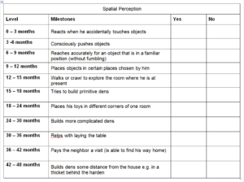
Work as a team to complete the assessment. Considering dividing the fields up to initially be completed by one or a pair of team members (e.g., Teacher of the Visually Impaired and Occupational Therapist working on Tactile Perception). Later review as a team and let the other team members validate or update the results.
This process takes time. Set a reasonable goal for your team to complete the entire assessment. Consider setting priority fields to be completed first based on previous assessment, IFSP or IEP goals, and team priorities.
Figure 1 Milestone page for Spatial Perception.
Don’t start with Social and Emotional Perception. Though the completion of the Social and Emotional Perception fields is very important when working with the student, these can be the most challenging fields to complete. You may want to start out with some of the other fields until you get more comfortable with the document. Input from the parents is really critical for the completion of the Social and Emotional fields. If the parents cannot be accessed for this information, do the best you can to complete these sections.

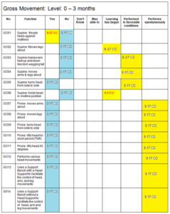
This Gross Movement example show that progress (dates highlighted in yellow) has been made since the first time (dates highlighted in blue) the child was assessed.
Figure 2 Gross Movement: Level 0-3 months of the Functional Scheme

You are developing a “profile” of the student’s skills. You are not looking for a “score” when you complete the Functional Scheme. This will become more evident when you complete the “Summary” on page 7.
Milestones give you a place to start working through the various segments in the field. This may mean that you can quickly move to a 9-12 month level without having to complete the 0-3 level segment. You will discover as you complete each segment whether the student is at a younger or older developmental level.
You are primarily concerned with “yes” and “no” answers the first time you complete the assessment. If you check “don’t know” try to find out. The other columns provide valuable information and a richer description of what the student is doing. This also helps to show incremental progress before a function is attained.
If all of the answers in a segment are “yes” you proceed to the next segment. (e.g., all “yes” in 0-3 months, go to the 3-6 months, etc.)
If only some of the answers in a segment are “yes” then the student is considered to be functioning at that developmental level. (e.g., 0-3 months only some “yes”, continue to focus on 0-3 month skills)
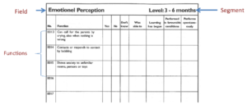
If all of the answers in a segment are “no” then the student is considered to be functioning at a younger age level segment where they show at least some “yes” responses. (e.g., 3-6 months all “no”, focus on the 0-3 month skills)
Figure 3 Emotional Perception: Level 3-6 months notes the field (Emotional Perception) top left, the segment in top right (Level 3-6 months), and the functions (specific skills) listed vertically down the the left side of the table..
The field appears in the upper left corner (Emotional Perception) the Segment in the right corner (Level: 3-6 months) and the Functions are listed in the left-hand column.

When considering how to interpret some of the “Functions” remember to place it in the context of the “Field” you are evaluating. Some skills are listed in slightly different ways because the meaning is different, therefore the skill is different. For example, reaching in the fine motor field is different than touching and grasping objects in succession to assure their presence in the special relations field.
It can be hard to know how to mark the correct column. Use this as a guide:
- Only mark “Yes” if the student is demonstrating the skill without support or prompting.
- If the student demonstrates the skill some of the time but still without a lot of prompting, mark it as “Learning has begun.”
- If the student can only demonstrate the skill with prompts in only a few environments with perhaps only a single person, this would be marked “Performed in favorable conditions”.
- “Performs spontaneously” is very much like “Yes” only a little more so. Lilli would say that this skill has become “part of the personality” of the student. They can do this skill without any apparent effort or without being given instruction; they just do it.
- “Was able to” refers to skills that were present a one time and now have disappeared. It is recommended not to use this column when marking the Functional Scheme the first time you use it. However, “was able to” can help document the loss of skills which can be very important.
- “Don’t Know” can be used when there are functions you can’t observe and information can’t be obtained from another source like the parents or therapist. For example, “Can call for the parents by crying, also when nothing is wrong”
Some functions that are marked “No” may be actual indicators of child progress, especially the functions that appear in the 0-3 month categories. These may be skills that are reflexive and should appropriately disappear as the child develops. It can be helpful to find out from the parents if this function was ever present.
Dating your responses (month/year) will help you document progress. If you develop your IEP goals and objectives based on targeted skills from the Functional Scheme, updating the “Summary” on a regular reporting schedule can be helpful. The person documenting should also include their initials, so if others disagree with the assessment, they can have a conversation with the person who initially marked the results.
When you are unsure what is meant in the Functions, it may be due to the Danish roots of this document. For example, “torch” means “flashlight”. You may also not know what the skill looks like, e.g., “Babbles homogeneously (a-gry, a-gry)”. Observe how a typically developing 0-3 month old babbles to get some idea of Dr. Nielsen’s meaning.
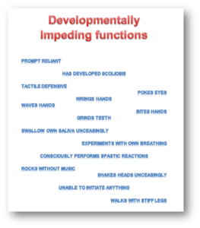
Developmentally Impeding Functions can include things like: pokes eyes, prompt reliant, walks with stiff legs, or has developed scoliosis.
Figure 4 Poster showing some of the Developmentally Impeding Functions in the Functional Scheme that include such items as rocks without music, prompt reliant, walks with stiff legs, etc.

Completion of the sections “Developmentally impeding functions”, “Toilet Skills”, “Personal Hygiene Skills” and “Eating Skills” is very helpful and gives great information to target in daily care and interaction with the student.
The skills listed as “Irrespective of level of development” help focus on things that may relate to behavior, use of technology, and so forth. Good information. The team could add items to this area easily to track progress and note undocumented behaviors of importance.
Individualize the assessment. Add additional functions that reflect appropriate developmental skills. That is the reason Dr. Nielsen has blanks in every section. If the child/adult can only perform the skill with the left or right hand for example, indicate this on the assessment.
Use pencil. In the beginning, you will make mistakes in your observations. Working in pencil will allow you to easily update the assessment.
Over time it is important to re-assess. Use the same functional scheme and work off of the old data. This will allow you to see progress or lack of progress over time.

