Texas School for the Blind & Visually Impaired
Outreach Programs
www.tsbvi.edu | 512-454-8631 | 1100 W. 45th Street | Austin, TX 78756

Social and Emotional Development: The Five Phases of Educational Treatment in Active Learning
The latest research on brain development stresses the importance of helping the child to develop a healthy self-identity and recognizing that emotional development is not in place at birth. This session will focus on the Active Learning strategies developed by Dr. Lilli Nielsen, what she called the Five Phases of Educational Treatment, that address social and emotional development in children who are visually impaired, blind, or deafblind.

Presenters: Kate Moss Hurst, Content Development and Website Management, Texas Deafblind Project and Julie Lemman, Private Consultant on Deafblindness, Austin, TX

Developed for
Texas Deafblind Outreach
Texas School for the Blind & Visually Impaired

This project is supported by the U.S. Department of Education Special Education Programs (OSEP). Opinions expressed here the authors and do not necessarily represent the position of the Department of Education.

Power Point Slides

Slide 1: Five Phases of Educational Treatment: Emotional & Social Development
Presented by
Kate Hurst, Active Learning Space Developer, Texas Deafblind Project
Julie Lemman, Private Consultant, Austin, TX

Slide 2: Introductions
Kate Moss Hurst
- Teacher of the Deaf and Hard of Hearing
- Deafblind Consultant with Texas Deafblind Project for 30+ years
- Currently Content Developer for Active Learning Space and Texas Deafblind Project websites
Julie Lemman
- Teacher of Students with Visual Impairments and Students who are DeafBlind , M.Ed. in Accessible Education
- Former Classroom Teacher at TSBVI with 8+ years experience working in both Residential and School Day programming.

Slide 3: Active Learning Space www.activelearningspace.org
- hurstk@tsbvi.edu
- https://activelearningspace.org/site-map-video-index/site-map/
- https://activelearningspace.org/principles/five-phases-of-educational-treatment/
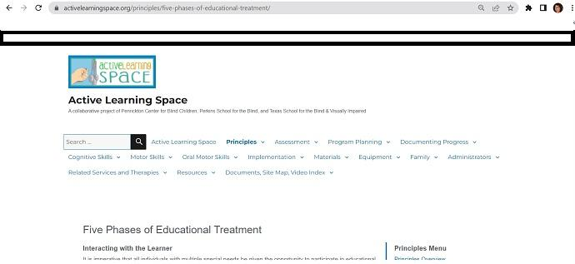

Figure 1 Screen shot of Active Learning Space website where content can be found.

Slide 4: Why is social-emotional development important?
- Trust and safety are required for learning
- Shapes brain circuitry development, especially executive functioning – the mental processes that enable us to plan, focus attention, remember instructions, and juggle multiple tasks successfully
- Extremely dependent on life-long support from others in multiple areas and benefit greatly from higher level social-emotional skills
- Social interactions provide richness and meaning, as well as support and safety
- Need specific instruction and support to develop social and emotional skills
- Key to development of communication skills
- Vital to self-identity and self-determination

Slide 5: Basics of Brain Architecture
Credit: Center on the Developing Child Harvard University - https://developingchild.harvard.edu/science/key-concepts/brain-architecture/

Slide 6: Theia montage
Figure 2 Theia video presentation.

Slide 7: Five Phases of Educational Treatment
- Identify the adult’s role in recognizing the emotional level of a learner and key strategies in building a trusting relationship between educator and student, parent/caregiver and child.
- Based on the works of Piaget related to the stages of typical child development
- Vygotsky: Vygotsky agreed with Piaget that the development of cognitive abilities takes place in stages and he also agreed broadly with the description of the stages however he viewed cognitive development as a social process where children learn from experienced adults (ZPD).
Slide 8: From Simply Psychology website
simplypsychology.org/piaget.html#:~:text=Piaget%20divided%20children's%20cognitive%20development,(4)%20formal%20operational%20thinking.
McLeod, S. A. (2018, June 06). Jean piaget's theory of cognitive development. Simply Psychology. www.simplypsychology.org/piaget.html
 | Piaget | Vygotsky
Sociocultural | Little emphasis | Strong emphasis
Constructivism | Cognitive constructivist | Social constructivist
Stages | Cognitive development follows universal stages | Cognitive development is dependent on social context (no stages)
Learning & Development | The child is a 'lone scientist', develops knowledge through own exploration | Learning through social interactions. Child builds knowledge by working with others
Role of Language | Thought drives language development | Language drives cognitive development
Role of the Teacher | Provide opportunities for children to learn about the world for themselves (discovery learning) | Assist the child to progress through the ZPD by using scaffolding

Slide 9: Piaget’s Stages of Cognitive Development
Stage | Age | Goal
Sensorimotor | Birth to 18-24 months | Object permanence  focuses on physical sensations and on learning to co-ordinate his body
Preoperational | 2 to 7 years old | Symbolic thought  beginning of stage child does not use operations, so thinking is influenced by the way things appear rather than logical reasoning  cannot conserve which means that child does not understand quantity remains the same even if appearance changes  is egocentric; he assumes that other people see the world as he does  ability to internally represent the world through language and mental imagery - becomes symbolic

Slide 10: 5 Phases and van Dijk approach

Lilli Nielsen
- Phase 1 Offering – build trust and determine appetites/aversions
- Phase 2 Imitation – follow the child’s lead
- Phase 3 Interaction – develop conversational turn-taking, serve-return
- Phase 4 Sharing the work – beginning level routines to learn sequence, partial participation
- Phase 5 Experiencing consequences – achieve independence and choice-making/outcomes

Jan van Dijk
Building trust and relationship
  - follow the child’s lead
  - learn appetites/aversions
  - resonance & imitation – engaging, confirmation of child’s actions
  - serve and return & turn-taking interactions
Routines and calendars
  - Anticipation of sequence of steps
  - Learning function of objects
  - Symbolization
  - Interest in participating (Phase 4)
  - Developing independence (Phase 5)

Slide 11: Phase 1 Offering
Purpose
- To convince the child to trust the adult has no intention of demanding that he does anything at all.
- To observe the reactions of the child.
- To learn likes and dislikes.
- To find out what may frighten.
- To learn child’s way of contacting, using this to assess the emotional level of the child.
- To introduce sound self-activity/self-determination.
- To provide basis for successful introduction to phase II.
Adult’s Role
- Absolutely no demands - only “request” that learner allow adult to play near learner - request is non-verbal.
- Gather materials and objects that reflect the child’s emotional level. (also sensory preferences & skills) Have multiple, if possible, so you each can have your own.
- Explore and experiment with objects in general area of the learner - if the learner desires, can reach out and touch, interact with, or take the objects.
- Adult makes an “offer” of activity and the learner can accept or decline that offer.

Slide 12: Phase 1
Video Example
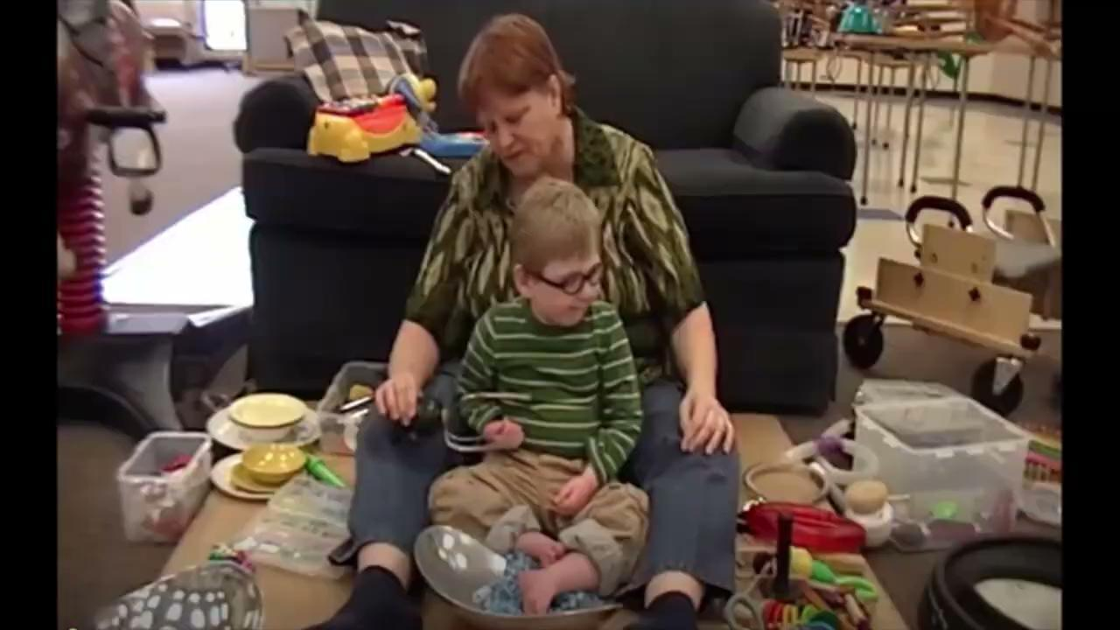
Figure 3 An adult sits on a Resonance Board with a young boy and uses the educational treatment of Offering (Phase 1) during an adult-child interaction.

Slide 13: Phase 2: Imitation
Purpose
- To increase the child’s interest in activities happening nearby.
- To increase the child’s ability to take initiatives.
- To increase the child’s belief in himself.
- To introduce activities and movements not as yet performed by the child.
Adult’s Role
- Set up environment with objects and activities that are highly motivating to the child.
- Begin by imitating actions of child on objects- good idea to have multiple numbers of an object.
- Introduce a new action with object and see if child will imitate him - if not, adult should go back to imitating action of the child again.

Slide 14: Phase 2
Video Example
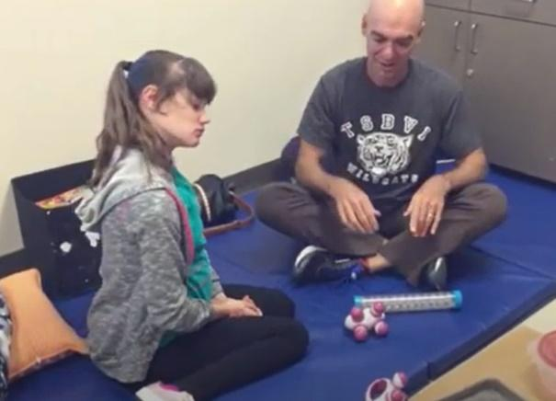
Figure 4 An adult sits on a floor mat with a young woman and uses Phase 2 Imitation to play with vibrators and rainsticks during an adult-child interaction.

Slide 15: Phase 3: Interaction
Purpose
- To help the child to learn sound dependency on one or several people.
- To help the child to initiate interactions.
- To enhance the child’s development of self-identity.
- To give the child the basis for social development.
Adult’s Role
- Set up situations and environments that foster interactive games.
- Be patient, wait for child to take a turn without trying to persuade him to act. Be quiet and still.
- If child is trying to complete motor skill that he has not yet mastered within level of motor development, adult can say, “You can help me.”
- If child uses his hands, provide opportunity for the child to familiarize himself with activity and participate. If child does not use his hands, model activity as close to child’s hands as he will allow.

Slide 16: Phase 3
Video Example
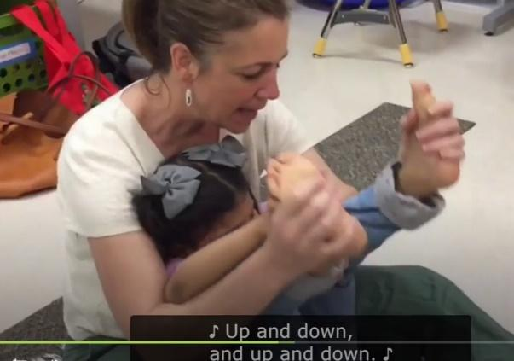
Figure 5 An adult holds the feet of a child and moves them up and down to a song using Phase 3 Interaction during and adult-child interaction.

Slide 17: Phase 4: Sharing the Work
Purpose
- To increase the child's experience of success.
- To involve the child in new social relationships.
- To increase the child's interest in acquiring new abilities.
Adult’s Role
- Set up environments/activities that give tasks to do based on previous successes. Initially tasks can be completed in few seconds-minutes without consideration for quality.
- Let child know part of task he will complete and part adult will complete. If child is reluctant to do task after being asked several times, suggest doing it together.
- Give child plenty of time to complete task, but if he still won't do it, consider if the task is too hard.
- In complex tasks adult may need to use various techniques (e.g. offering, imitation) for different parts.
- Let child know how long task will last and what will follow… think calendars and an established schedule.

Slide 18: Phase 4
Video example
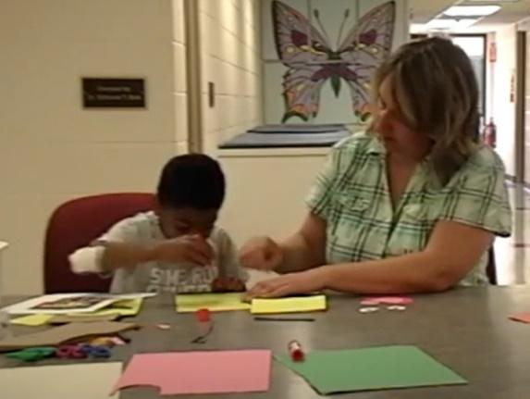
Figure 6 An adult and a young boy work together to make a paper-bag puppet using Phase 4 Sharing the Work during an adult-child interaction.

Slide 19: Phase 5: Experiencing Consequences
Purpose
- To help the child to endure meeting demands.
- To help the child to endure changes in life.
- To help the child to feel self-confident, which is fundamental to the ability to make decisions about his own life.
- To establish the basis for the sense of responsibility.
Adult’s Role
- Model how consequences work through discussion of adult’s actions. (e.g., “I have to stop playing and cook dinner, or you will not have anything to eat.”)
- After a time adult begins to set up situations where child can experience consequences of his actions. (e.g., “If you want me to pour more milk, you must put your glass on the table.”)
- Accept less than perfect response from child.
- May need to offer encouragement through prompting or modeling. (e.g., “See you can put your glass here.”)
- Goal: child begins to understand choice-making.

Slide 20: Phase 5
Video example
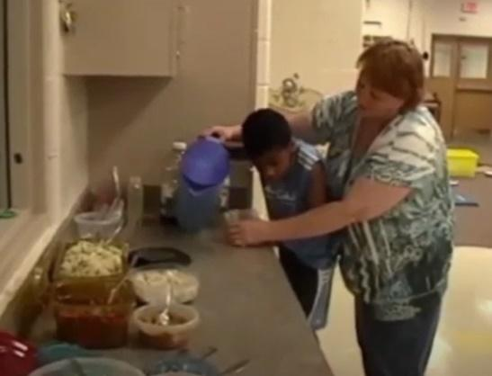
Figure 7 An adult and young boy work on serving his own lunch using Phase 5 Experiencing Consequences during and adult-child interaction.

Slide 21: Final Points
- Be a good observer - judge which educational treatment to use in any interaction.
- May use multiple educational treatments in any one interaction. If child withdraws or resists interaction, drop back to a lower level of treatment.
- Meeting a child for the first time or introducing new materials or activities, start with Phase 1 and see how child responds before moving to higher phase.
- If child is having a bad day, feeling ill, or doing an activity with someone new, may need more support and fewer demands.
- Generally takes a child a long time to be able to interact at the phase 4 and 5 levels. At these levels the child is able to manage some stress consistently.

Slide 22: Additional Resources
Job One for Educators: Becoming a Good Playmate
- This is an article from Stacy Shafer and Kate Moss Hurst. If children learn through play, then we must become better playmates in order to facilitate better learning for the child.
Deafblind Interaction section of the Texas Deafblind Project website
- Learn more about interaction and about the Zone of Proximal Development
NCDB Practice Guide on Active Learning
- Hot off the presses this document provides some basics about Active Learning.
TSBVI Active Learning modules
- Want to dive deeper? These online self-paced courses for free and cover much of the content included on Active Learning Space.

Slide 23: Next: Addressing the Gen Ed Curriculum
- April 13 – 3:00-4:00 PM CST
- Utilizing Active Learning to Provide Instruction in the General Education Curriculum
- Program Planning
- Implementation – Content Domains
- Submit questions or needs in advance to hurstk@tsbvi.edu

