Active Learning Space

https://activelearningspace.org/

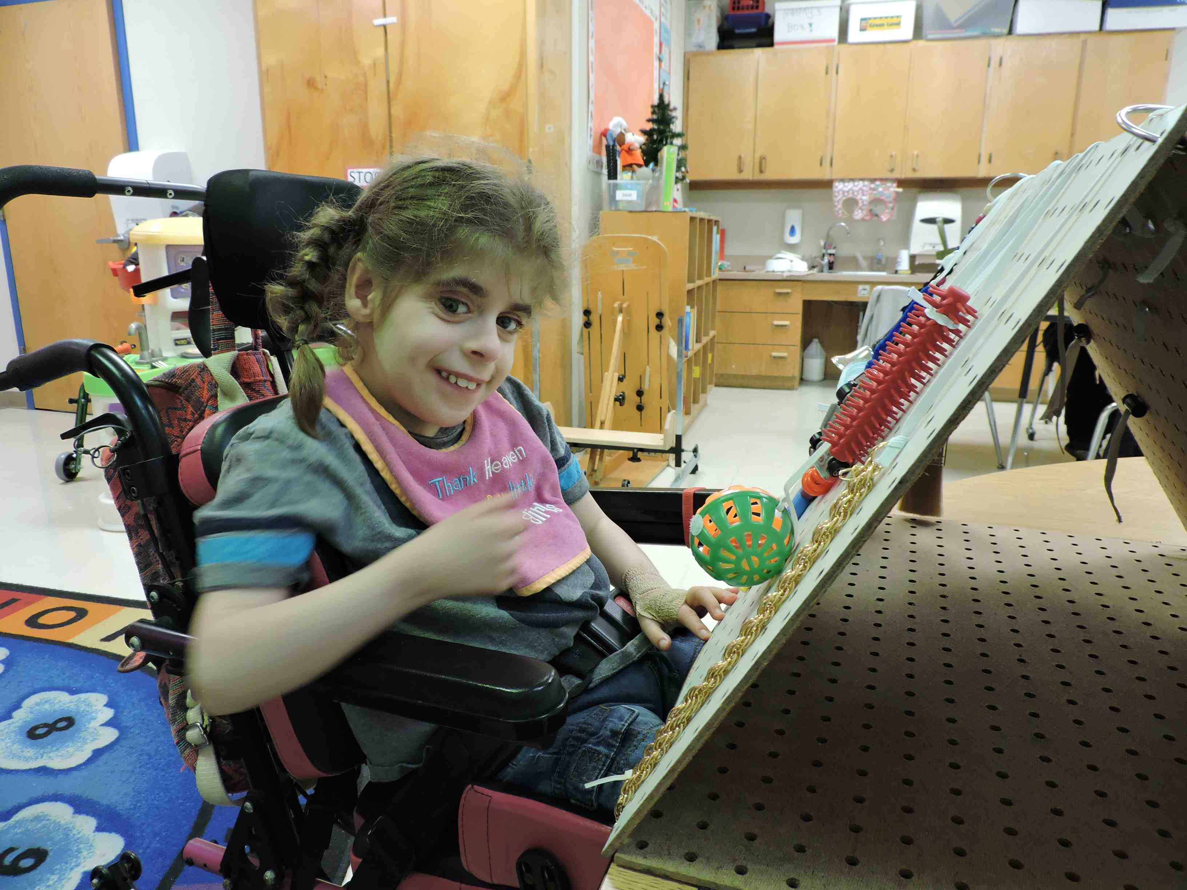

Do you work with students with
multiple disabilities or
complex learning needs?

Learn about the theory of Dr. Lilli Nielsen, which
emphasizes simple ways to change the environment so
that a child becomes an active participant and an engaged learner.

Videos, tips for implementation, materials, questions, and more!

For learners in the 0-48 month range developmentally

Subscribe to our eNewsletter!

Penrickton Center for Blind Children | Perkins School for the Blind
Texas School for the Blind and Visually Impaired

